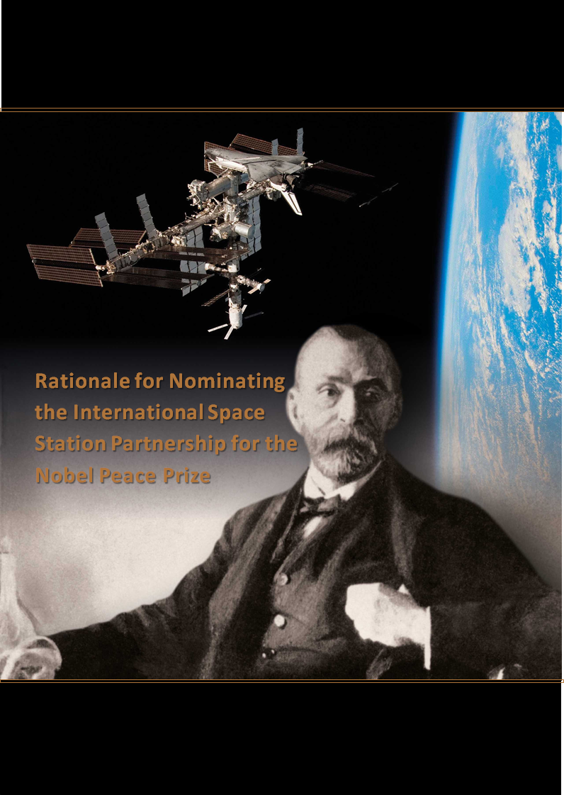
in 2016

“The space station is this bright star shining overhead. There are troubled areas in the world, but the station stretches well above and beyond that. We may come from very different backgrounds, but we can still come together and develop the greatest engineering achievement of mankind in peacetime.”
Sean Fuller, NASA’s Human Spaceflight Director in Russia, 2014

“Space is almost, I would say, the number one activity in the world today in promoting international cooperation. There is an International Space Station, we don’t have international something else…In space they work together, they train together, and at the end American astronauts are taken to the International Space Station by Russian Soyuz. It’s like a dream, but it happens in space.”
Isaac Ben-Israel, Israel Space Agency Chairman, 2015

Rationale for Nominating the International Space Station Partnership for the Nobel Peace Prize in 2016
Preface 4
Introduction 5
Global cooperation in a challenging historical and political context 6
Managing and coordinating international technical collaboration 8
The intergovernmental agreement: a template for international cooperation 10
A practical approach to political realities 12
A testament to progress and peace 14
Appendix I: ISS modules and major components 16

Preface

On November 2, ISS celebrated its 15 year anniversary of continuous human habitation over 45 crewed expeditions encompassing crews from 17 countries. In those 15 years, ISS educational activities have inspired more than 42 million students globally and crews have performed scientific experiments on behalf of 93 countries. Thousands of images shared on social media have taught a generation to see the world as it appears from space, without boundaries.
The ISS partnership, whose motto is “Off the Earth, For the Earth,” continues to push boundaries in all aspect of human life. 2015 saw the beginning of the One Year Mission, a pioneering experiment in which Roscosmos cosmonaut Mikhail Kornienko and NASA astronaut Scott Kelly spend 350 days aboard ISS, about twice as long a usual crew rotation. The mission has been called an embodiment of significant international collaboration in biomedical risk reduction. Data from the crew members will be shared between their countries of origin as they seek to find and solve the challenges of long duration spaceflight.
In remarks to the US Council on Foreign Relations on November 12, NASA Administrator Charles Bolden underscored the significance of the ISS program in 2015: “Today, a child who is 15 years old or younger has lived every day of her or his life while human beings from multiple countries are living and working together in space aboard the International Space Station. I maintain that the Space Station ought be considered for a Noble Peace Prize. Think about this: tens of thousands of people from across 15 countries have been involved in its construction and operations all working toward common goals of discovery, understanding, and human progress.”
Keeping ISS going is not easy. It requires constant cross-cultural diplomacy and negotiations at all levels. The station just emerged from one of the most difficult diplomatic feats in its history with the agreement between US space agency NASA and Russian Federation space agency Roscosmos to extend the life of ISS out to 2024 from its original termination date of 2020. As director of the White House Office of Science and Technology, John Holden, remarked on the 15th anniversary of ISS habitation, “The international partnership that built and maintains the Station is a shining example of what humanity can accomplish when we work together in peace.”
In 2014, the crews of the Internationl Space Station received the Westphalian Peace Prize, a semi-annual award commemorating the conclusion of the 30 Years War and the diplomatic process that ended it. The jury called ISS a clear demonstration that “peaceful international cooperation of partners from very different cultures has proven to be possible.”
The astronauts and cosmonauts who form the rotating crews of ISS are, indeed, remarkable people and their cross-cultural success is worthy of note. But the peaceful cooperation they symbolize reaches beyond the crews of ISS to its very foundation: the International Space Station Partnership.

Introduction
The dawn of this millennium will be distinguished in history for the extraordinary global partnership, focused on the peaceful use of space, which drew fifteen nations together over the last quarter century for the planning, design, development, construction, and operation of the International Space Station (ISS). ISS, built for the benefit of all humankind, is the largest peace-time endeavor in human history; there has not been any other multi-national endeavor of a greater magnitude or complexity since the world wars of the 20th century. Visible in the night sky to all people on Earth, ISS is a beacon of peace and hope, and a model for international cooperation on Earth and in space.
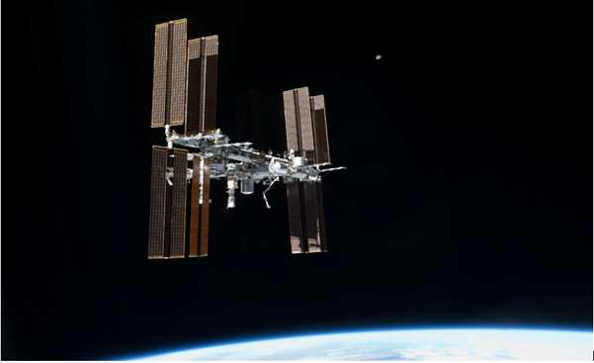Figure 1: The International Space Station in orbit (Credits: NASA)
ISS is a human outpost in space—about 400 km above Earth— dedicated to peaceful international exploration of space and research to benefit humanity on Earth. The structure itself is an amalgam of pressurized modules and supporting infrastructure that have been built, financed and launched by an international partnership, comprised of fifteen nations: Belgium, Canada, Denmark, France, Germany, Italy, Japan, the Netherlands, Norway, Russia, Spain, Sweden, Switzerland, the United Kingdom, and the United States. These nations are organized into the five principal partners (referred to herein as the Partners or the Partnership): the Canadian Space Agency (CSA); the European Space Agency (ESA), representing 11 participating ESA member states; the Japan Aerospace Exploration Agency (JAXA); the Russian Federal Space Agency (Roscosmos); and the United States National Aeronautics and Space Administration (NASA).
Researchers from all over the world are using the huge complex of orbital laboratories to expand scientific knowledge, develop and test the means to enable long-duration human space flight, and improve life on Earth. It has been continuously occupied by an international crew since November of 2000. The location of ISS in Low Earth Orbit allows the observation and study of Earth and the heavens, and provides a unique laboratory for research on the effects of microgravity and the space environment on humans, materials, and technology.
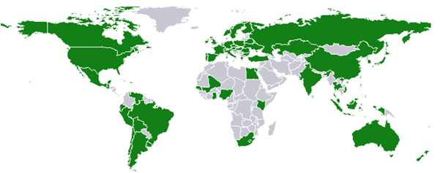Figure 2: All highlighted countries have participated in ISS research and education activities (Credits: NASA)
The Partnership has reached out to researchers from all over the globe and experiments have flown on ISS from 93 countries. Research on the ISS has been and is being conducted in the areas of high energy particle physics, Earth remote sensing, geophysics, protein crystallization, human physiology, radiation, plant and cultivation experiments, fluids and combustion, material science, and biology. Many investigations conducted aboard ISS have application to terrestrial medicine as well, including, for example, experiments in the areas of bone and muscle health, immunology, and the advancement of new diagnostic systems.
Over a period of more than two decades, the Partnership has proven to be flexible and resourceful in adapting to changes and meeting challenges. The success of the Partnership in constructing, operating, and utilizing ISS is guided by the principle that all its activities are for peaceful purposes and uses. The unprecedented achievements of the Partnership in promoting peace are particularly salient in three areas: 1) conducting worldwide cooperative activities in a challenging historical and political context; 2) managing and coordinating international technical collaboration; and 3) pioneering new approaches for conducting international cooperation.

Global Cooperation in a Challenging Historical and Political Context
A review of the half-century since the beginning of the space age illustrates the significance of the ISS program and highlights how it transformed the space age paradigm from competition to cooperation. The space age is generally regarded to have begun in the late 1950s with the launch of Sputnik I. The fear and apprehension about the future that the launch of Sputnik I engendered in the U.S. is often credited as a factor leading to the creation of NASA by legislation in 1958, less than a year later (see “Sputnik and the Creation of NASA; A Personal Perspective” by Eilene Galloway). The space age quickly became a “space race,” an analog to the “arms race,” between the U.S. and the Soviet Union in the 1960s to land a man on the moon. Cold War tensions were dangerously high during the 1960s and the space race was widely perceived as a struggle for international prestige and dominance. Military strategists speculated on the possibilities of space as a theater for military operations—literally, the next “high ground.” Although there was at least one significant instance of international collaboration between the adversarial superpowers, the Apollo-Soyuz (Union) Test Project in the 1970s, generally the U.S. and the Soviet Union proceeded in solitary determination and jealously guarded their technological achievements.
In his January 1984 State of the Union address, the President of the United States directed NASA to collaborate with international partners “to develop a permanently manned space station.” NASA officials had already met with potential partners from Europe, Canada, and Japan, solicited their involvement, and received affirmations of interest. This degree of international collaboration and cooperation on a peaceful space project signaled the beginning of a new era in space exploration and the creation of a new model for peace here on Earth. Almost a decade later, when the ISS partnership was extended to Russia, the former Cold War adversary of the West, the change in direction was highlighted and solidified.
The space programs of the U.S. and Russia had evolved from Cold War instruments to a point where societies once separated by literal walls and symbolic “iron curtains” had become partners in an ISS program that is an icon of post-Cold War peaceful cooperation.
It is hard for any one country to balance competing national priorities and make and sustain a long term commitment to a particular project. It is all the more difficult for a coalition of disparate countries to maintain their political will and commitment to a long-term project where it seems any payoff, in the form of scientific discoveries, will be realized in the distant future after construction is complete. And, in the case of ISS, there was a long gestation period after early attempts to organize the coalition. Then there was also a long, concurrent phase of detailed, technical planning before construction and assembly in orbit could even begin. The fluctuations of all those national economies and the vicissitudes of their internal politics over that period greatly increased the difficulties of maintaining a long-term commitment.
One of the lessons of the ISS is borrowed from exploration in general: there are often unexpected benefits from the journey as well as from the attainment of the objective. ISS has helped stimulate aerospace industries; led to new and improved technologies; inspired children to pursue careers in math and science; and resulted in new knowledge, understanding and insight. But more importantly, the effort involved in sustaining the program and integrating national interests and investments has transformed what was a sometimes fragile and precarious coalition at its inception into a strong and united international partnership committed to common peaceful goals.
ISS is intended to serve as a foundation for further international exploration of space. The discoveries that emanate from it will benefit all humankind. ISS is a truly international project; none of the five principal partners could have accomplished the construction or operation of this remarkable space station without the others.
The nature and degree of international cooperation among and between the partners to sustain the effort and maintain the partnership is unprecedented and serves as a model for future collaboration on space exploration and other complex peaceful international projects.

Managing and Coordinating International Technical Collaboration
The proximate goal of the ISS program has been to create shared multi-disciplinary laboratory facilities in the micro-gravity environment of low Earth orbit. The problems involved in managing and coordinating the technical collaboration involved in such an undertaking are constant and complex and the scope and breadth of the effort is difficult to comprehend. The various parts and modules were built in facilities in Asia, Europe, and North America. It took over 100 space flights of five different types of launch vehicles to ferry them to orbit. Multi-national crews working with robotic assistants assembled everything piece by piece upon its arrival in space during more than 160 spacewalks.
The modular elements were approved and funded by different national processes. They were built in different countries with different languages, measurement systems, and cultures. Modules and other components had to be built to endure the logistical challenges of shipment to a variety of launch sites and then withstand the extreme dynamic forces of being launched into space. It is truly amazing that they have all fit together and functioned nominally after being assembled for the first time in the harsh and unforgiving environment of space. It is also evidence of the effective management, and remarkable technical teamwork, of a disparate international workforce spread over three continents and eight time zones. Unlike any international cooperative effort in history, ISS teamwork extends hundreds of kilometers above Earth, supporting multi-national crews who train together on Earth and live and work together in space.
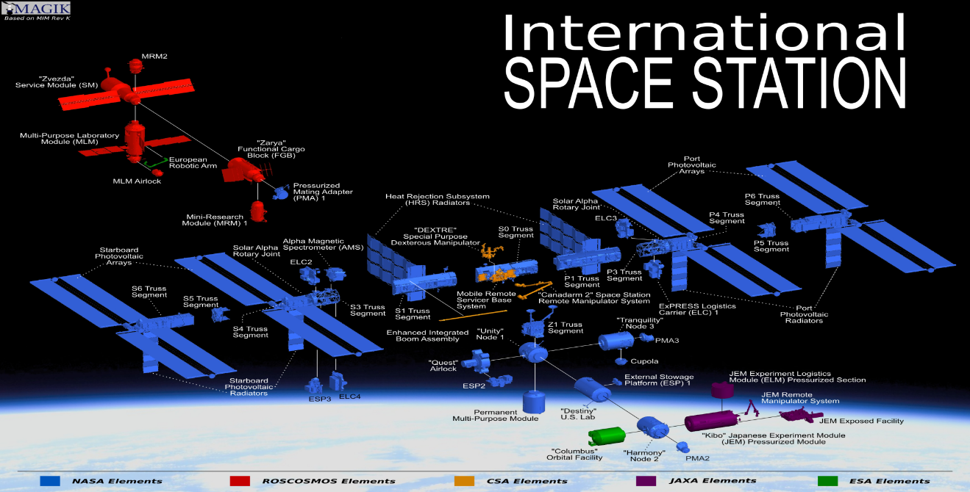
Figure 3: Schematic of the International Space Station, color coded by nationality (Credits: NASA).
The on-orbit assembly of ISS began in 1998 with the Russian-built Zarya module and it grew steadily over the next thirteen years, with the exception of a two and a half year hiatus after the Space Shuttle Columbia tragedy in 2003. Construction was considered complete in May of 2011, although ISS continues to be augmented and enhanced. The station is comprised of modules and major components from Russia, the U.S., Italy, Japan, Canada, and participating ESA nations. For more information on the modules contributed by these partners, see Appendix I.
An international fleet of space vehicles routinely rotates crews, delivers propellant and supplies, and provides material and equipment for science experiments. Their supplies and schedules are tightly coordinated – any disruptions could introduces difficulties or even danger to the continuously maintained crew onboard the station. In the history of ISS, the Partners have never exhibited lack of coordination or allowed Earthly disputes to affect crew members of any nationality. Before their retirement in July of 2011, NASA’s Space Shuttle vehicles were launched 37 times from the Kennedy Space Center (KSC) to ISS. The Space Shuttle delivered many of the largest ISS elements and modules to orbit and was used to rotate crewmembers as well. Roscosmos launches the Soyuz spacecraft and the Progress cargo vessels from the Baikonur Cosmodrome in Kazakhstan. The Soyuz carries a crew of three and, in addition to transporting crew, it also serves as an emergency rescue or evacuation vehicle. The Proton launch vehicle has also launched some of the ISS elements to orbit from Baikonur. ESA launches the Automated Transfer Vehicle (ATV) cargo ship on the Ariane launch vehicle from Kourou, French Guiana. Five ATVs, the Jules Verne, the Johannes Kepler, the Edoardo Amaldi and the Albert Einstein, and the Georges Lemaître, have docked with ISS to deliver cargo and propellent. JAXA has launched five of an anticipated nine Kounotori (White Stork) H-II Transfer Vehicles (HTV) cargo vessels from Tanegashima, Japan. Two commercial cargo resupply companies are under contract. The SpaceX Falcon 9 launch vehicle, and its Dragon spacecraft; and Orbital Science’s Antares launch vehicle, and its Cygnus spacecraft, have both delivered cargo to ISS. With 12 to 15 spacecraft from the Partners arriving and departing during a typical year, ISS is a busy hub of activity and the management and planning of this enterprise–both in terms of logistics and industrial economics—is quite complex.
Another manifestation of the international peaceful cooperation exemplified by the ISS is a worldwide control network that operates continuously 24 hours a day, seven days a week, every day of the year. It consists of NASA's Mission Control Center (MCC-H) in Houston, Texas, and the Russian Mission Control Center also known by its Russian acronym, TsUP, at Korolov, outside Moscow. MCC-H and TsUP monitor and control core ISS elements and infrastructure, in addition to flights of spacecraft that visit the station. Control Centers all over the world operate and control various modules and systems: ESA’s Columbus Control Center in Oberpfaffenhofen, Germany controls the Columbus module; ESA’s ATV Control Center in Toulouse, France controlled flights of the ATV; CSA’s Control Center in St. Hubert, Canada controls and monitors the Mobile Servicing System during robotic operations; and JAXA’s Control Centers in Tsukuba, Japan control the Kibo and the HTV. This network ensures that ISS crews are never cutoff from Mission Control – there is always someone available to address any issue, somewhere in the world.
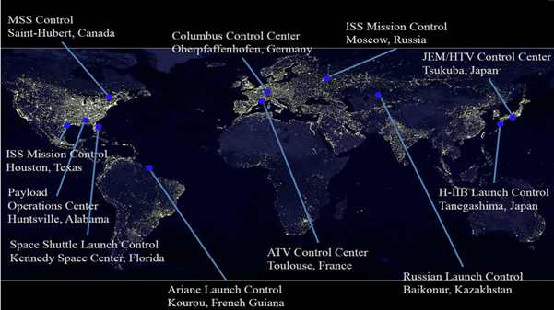
Figure 4: Control Centers support ISS from all over the world (Credits: NASA)
Adding to the technical collaboration involved in building, operating, and utilizing ISS is the collaboration that includes bilateral and multilateral agreements that address barters and the trading of rights, obligations, and responsibilities.
A module built in Russia was financed by the U.S. and launched from Kazakhstan. A cargo carrier was built mostly in Italy, launched from French Guiana, monitored by a control center in France, and designed to dock with a module built in Russia. Another cargo carrier was built in Japan and designed to attach to a module built in the U.S. using robotic elements built in Canada.
These examples illustrate how the partners have had to constantly manage and coordinate a complex and interdependent web of relationships and responsibilities—all crucial skills in promoting peaceful cooperation.
In May of 2009, with three full laboratories, the addition of regenerative life support systems, and additional pressurized volume, ISS was complete enough to double the size of the normal crew complement from three to six for the first time. Whereas the previous normal crew complement of three had to devote almost all of their time to construction and maintenance, with a crew of six it was finally possible to increase the amount of time spent on science and utilization by a significant factor. Science has long been recognized as an inherently collaborative and international endeavor. The greatly expanded capacity to conduct science on-orbit established ISS as a model of international collaboration and as a template for peaceful cooperation on a trail that leads out into the solar system and on to the stars.

The Intergovernmental Agreement: a Template for International Cooperation
The International Space Station is also a pathfinder and role model in governance. Making the political intentions, financial resources, technical capabilities, and operational structures of 15 participating states work together was not only a challenge from a technical point of view, but also required the building of new roads in an uncharted legal universe. A lot of pragmatism and compromise was necessary from all sides to work out the legal instruments that were both adequate to build and operate such a complex new structure in outer space, and compatible with the existing legal traditions and constraints of the participating states on Earth. Sharing commonly- and separately-owned interdependent facilities high above any national territory and legislation was not an easy undertaking from a legal point of view. The outcome can serve as a model for other future projects in international cooperation and thus contribute to facilitating and improving international political relations and political stability.
The Outer Space Treaty of 1967 provides the legal foundation for most outer space activity, however it does not address the practical implementation of scientific development or commercial exploitation of outer space in a concrete program by a consortium of partner states. Thus, there was the need to complement the UN space law system by special international agreements and rules tailored to the specific needs of the International Space Station.
The main legal basis to establish a long-term and mutually beneficial relationship among the ISS Partners is the so-called Intergovernmental Agreement (IGA). This agreement specifically defines the civil international Space Station program and the nature of this Partnership, including the respective rights and obligations of the Partners in this cooperation. By providing flight elements to the ISS, each Partner acquires certain rights to use the station and participate in its management.
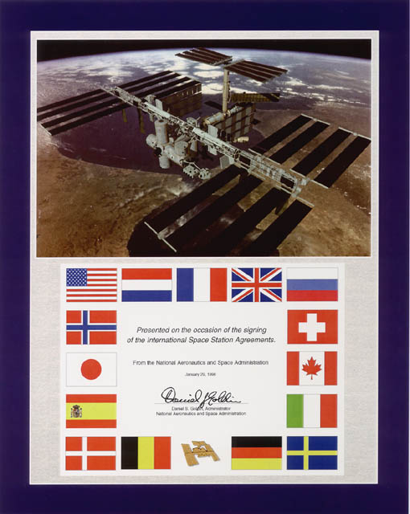
There are many references in the IGA to the status of the ISS as an international “civil” station. In at least three separate places (the preamble; Article 1, Paragraph 1; and Article 14, Paragraph 1), the IGA states that the ISS is dedicated to and reserved for peaceful purposes and uses. There are a series of bilateral agreements referred to as Memoranda of Understanding (MOUs) between NASA and the other four space agency partners also signed in 1998. The MOUs outline ISS responsibilities, obligations and rights between the agencies. The last sentence of paragraph 14.1 in Article 14 of the MOUs, “Space Station Evolution,” states: “The Space Station together with its additions of evolutionary capability will remain a civil station, and its operation and utilization will be for peaceful purposes, in accordance with international law.”
The IGA reflects the principle first laid down in the Outer Space Treaty and later taken up in the UN Registration Convention, which states that a state shall register an object launched into outer space in an international register kept by the United Nations and shall then exert jurisdiction and control over that object while that object is in outer space.
The ISS Partner states opted to separately register each constituting ISS flight element, and therefore each Partner individually registered with the UN the components which it provided to the station. Consequently, the IGA says that an activity occurring in or on an ISS flight element shall be deemed to have occurred in the territory of the Partner state of that element's registry. Since for the IGA the European countries participating in the ISS formally count as one partner, represented by the European Space Agency (ESA), the IGA further stipulates that for intellectual property issues, such as patents, arising from the scientific and commercial use of the ESA-registered elements any European partner state may deem the activity to have occurred within its territory.
Figure 5: Commemorative plaque presented on January 29, 1998 on the occasion of the signing of the IGA
In that respect, the legal regime on the ISS, despite the unique and unprecedented nature of this particular international cooperation in space, does not deviate much from the classical principles of international law that since long govern the maritime world, where ships at sea are treated in a very similar view.
Where the ISS really innovates from a legal point of view and reflects a new spirit in international law is in the field of criminal jurisdiction. In the IGA, the partner states established rules for the exercise of criminal jurisdiction, which deviate from the approach taken in the Outer Space Treaty, where the general principle governing criminal jurisdiction provides that the state of registry exercises jurisdiction over the space objects registered with the UN, including all persons onboard these objects, regardless of their nationality.
However, in the case of a joint program, such as the ISS, the UN Registration Convention also authorizes the participating states to agree among themselves on the application of legal rules other than the state of registry, and that is what the ISS partners did.
They agreed on a specific mechanism for the exercise of criminal jurisdiction onboard the ISS where the right to exercise criminal jurisdiction belongs, in principle, to the home state of the crew member who committed a crime, irrespective of where the crime took place, in a flight element registered by its own state or in another Partner’s module. For example, if a Japanese astronaut commits a crime in a European ISS module, Japan and not a European Partner state will have primary criminal jurisdiction over its own astronaut.
This shows the trust among the Partner states of ISS, that they all share the same legal values and the same basic understanding of what is ethically right and wrong. They do not fear to expose their own national astronauts to undue risk when they are living and working on the ISS together with astronaut colleagues whose acts may be judged on the basis of a national criminal law system that differs from that of their own home country. This also reflects a very pragmatic approach since everybody is supposed to have at least a fair knowledge of the rules of his or her own criminal law, whereas it could not be expected, for example, that a European astronaut will know all the implications of Japanese criminal law before entering the Japanese Kibo laboratory on ISS.
The IGA provisions on criminal jurisdiction on ISS have been complemented by a so-called Code of Conduct which also set new standards for cooperation in an international context of persons stemming from various national and cultural backgrounds. The ISS Code of Conduct establishes the chain of command on-orbit, a management hierarchy, and the relationship between ground and on-orbit management.
The general spirit that rules the Code of Conduct is that ISS crewmembers must maintain mutual confidence and respect through an interactive, participative, and relationship-oriented approach, which duly takes into account the international and multicultural nature of the crew and mission. No ISS crew member may give undue preferential treatment to any person or entity in the performance of ISS activities.
The International Space Station constitutes the first permanent civil settlement of human beings in outer space. Its legal regime within the principles established by the various agreements and conventions on outer space by the United Nations, together with the rules agreed upon by the Partner states in the Intergovernmental Agreement, an additional set of bilateral Memoranda of Understanding, and the Code of Conduct will not only enhance the scientific, technological, and commercial use of outer space; the innovative legislative model that has been worked out for the ISS is a model for peaceful international cooperation that may be extended in the future to other outer space human settlements and to large terrestrial cooperative endeavors, alike.

A Practical Approach to Political Realities
Although the orbit of ISS appears as fixed and predictable in the evening sky as other celestial bodies, there are many who are unaware of how tenuous and uncertain, even unlikely, the project was from its beginning. The genesis of the ISS dates back to a series of meetings between the U.S. and potential partners in the early 1980s. In May of 1982 Japan established a Space Station Task Force. A month later ESA conducted a study of station participation requirements. In January of 1983 CSA conducted a study of an advanced robotic arm for the station. A “core U.S. Space Station” known as “Space Station Freedom” was envisioned at an early stage but numerous funding problems and redesigns ensued into the early 1990s. This initiative eventually led to the signing of the 1988 Intergovernmental Agreement (1988 IGA) among the U.S., the state partners of ESA, Japan, and Canada.
After the break-up of the Union of Soviet Socialist Republics, Russia was invited to join the program in 1993. The original coalition benefited greatly from the space station experience the Russians brought to the partnership. Russia already had its own Mir space station (in orbit since 1986) and an agreement between the U.S. and Russia in 1993 led to a period of collaboration throughout the mid-1990’s when U.S. astronauts visited Mir and Russian cosmonauts flew on the Space Shuttle. Long and difficult negotiations between all the Partner nations eventually led to the signing of a new IGA in January of 1998, stating that the U.S. and the Russian Federation will produce “elements which [will] serve as the foundation” of the ISS and that the “European Partner,” Japan, and Canada will provide elements to significantly enhance “an integrated International Space Station.”
The success of ISS can be attributed, in no small part, to its management structure prescribed by the IGA and the dedicated cadre of visionary leaders the partners have produced that have nurtured it from a concept to an operating reality. Each partner has the responsibility to manage and operate the hardware it provides, but the various elements are interdependent and must be operated as an integrated system. The IGA assigns NASA the lead role in overall management and coordination but provides for the participation of all the Partners in the management of the integrated facility and sets “decision making by consensus” as the goal. The multi-lateral management function is performed by a number of management bodies including the ISS Multilateral Coordination Board (MCB) at the highest level and the Space Station Control Board (SSCB) at the next highest level; representatives of the partner space agencies regularly meet in these forums and discuss and resolve a wide range of difficult issues.
There are numerous points in the history of ISS where the Partners and their sponsoring national states had to compromise and sacrifice their individual interests in the interest of the whole. At any one of these critical junctures the entire communal effort could have unraveled and the project would have died. The various ISS management bodies have wrestled with the transportation and staffing crisis precipitated by the Columbia tragedy; countless technical challenges; diverse political and bureaucratic obstacles; fluctuations in support, priorities, and funding; and yet, over a period of decades, the Partnership has met and overcome every challenge, and the vision has endured, come to fruition, and flourished.
The Space Age began only five decades ago with all the dueling potential for good and evil typically incident to major technological advances. Satellites, spacecraft, and their passengers, studying Earth and exploring the near reaches of the solar system, have taught us much about our fragile planet and its place in our solar system, the Milky Way galaxy and the universe. At the same time, intercontinental ballistic missiles were developed and employed that can threaten every place on the planet.
The amazing technological progress of the last century gives one pause and makes an open mind wonder what is possible and where we will go in the next hundred years. Our vision is often short sighted when it comes to predicting the potential of new technology. Who could have imagined a century ago how aviation would transform both warfare and transportation? But given the predilection of humans to gaze over the horizon and wonder, it seems certain that we will continue to explore. And in the sky above and before us, the most expansive and challenging frontier imaginable beckons.
The ISS Partnership has laid the foundation for the next voyages of discovery and exploration and for what is sure to be larger international expeditions. International cooperation that traces its heritage to this ISS Partnership will be for peaceful purposes and uses. Exploration that is based on the most basic principles inherent in the IGA will be grounded in peace.

A Testament to Progress and Peace
This is a nomination for the semi-autonomous partnership that, operating within the parameters of their various national charters and budgets, has managed to integrate and coordinate their activities and contributions into the framework of an incredibly successful international program that has sustained a human presence on ISS for more than 15 years. Any prize should be shared equally amongst the five principal partners and awarded to representatives of CSA, ESA, JAXA, NASA, and Roscosmos together.
Just 100 years ago, the world was poised on the precipice of two devastating world wars. A new technology, aviation, was then in its infancy and would be utilized by military powers with horrific impact in those wars. Throughout much of the 20th century, people looked up at the sky and feared that bombs, missiles, and planes would rain destruction down on them. Few could have imagined then that, at the beginning of the 21st century, former enemies from those great wars would be living and working together peacefully in an orbital outpost.
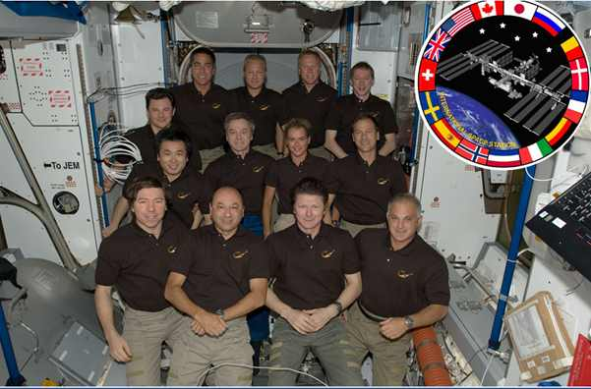
Figure 6: On July 17, 2009, representatives of all the partners were onboard ISS simultaneously (Credits: NASA).
ISS has set an example of how the nations of the world can cooperate and live and work in this new arena together for the common good. It is an amazing engineering, technological, and scientific marvel of unprecedented proportions for peaceful purposes. But the most significant outcome of the ISS Partnership is the enhanced worldwide security and peace that is the inevitable consequence of so many countries working together and collaborating for peaceful purposes and uses. As it orbits the Earth every 90 minutes, ISS inspires hope, not fear. Young people, who have never known a world without humans in space, have good reason to believe that the world they inherit will be a better place because of the ISS and the extraordinary Partnership that created and sustains it.
Now, just about anyone who lives on Earth can look up on a clear night and see the International Space Station transit the starry sky. It outshines all the other satellites in the heavens and is a powerful testament to international progress and peace.

For all the aforesaid reasons, we propose the International Space Station Partnership of
The Canadian Space Agency (CSA), Canada
The European Space Agency (ESA), Participating European Nations*
Japanese Aerospace Exploration Agency (JAXA), Japan
National Aeronautics and Space Administration (NASA), United States
Roscosmos, Russian Federation

for the Nobel Peace Prize.

*Belgium, Denmark, France, Germany, Italy, Netherlands, Norway, Spain, Sweden, Switzerland, United Kingdom

Appendix I: ISS Modules and Major Components

Zarya (Sunrise) Functional Cargo Block (FGB)
Launched on November 20, 1998, the Russian-built, U.S.-financed module was the first element of the ISS. During the early stages of ISS assembly, the FGB was self-contained, providing power, communications, and attitude control functions. The FGB is used today for propulsion and storage.

Unity (Node 1) Connecting Module
The U.S.-built Unity Connecting Module provides docking ports for several of the ISS component modules including the U.S. built Quest airlock, the Destiny Laboratory and Tranquility/Node 3. The Multi-Purpose Logistic Modules (MPLM) were also berthed to Unity on numerous occasions. The three MPLMs were transported back and forth on the Space Shuttle and functioned as portable moving vans for cargo, supplies and equipment. All three comprise a U.S. system built in Italy under barter agreements with NASA. One of the MPLMs was converted into a Permanent Multipurpose Module and attached to Unity as a permanent module on one of the final Space Shuttle flights to the ISS.

Zvezda (Star) Service Module and Nauka (Science) Multipurpose Laboratory Module
The Russian-built Zvezda Service Module contains the station’s original living quarters and life support systems. The Russian-built Multipurpose Laboratory Module (MLM, Nauka or Science) is planned for a future launch and will be used for docking and cargo and function as Russia’s primary research module as well as providing an airlock from which science experiments can be transferred between the pressurized ISS cabin and the vacuum of space.

Destiny Laboratory
The U.S.-built Destiny Laboratory is the primary research facility for U.S. payloads and provides additional life support and robotic capabilities. It has a capacity of 24 rack locations and accommodates 13 laboratory racks for research. It also features an optical window which is utilized to conduct several forms of earth observations studies.

Mobile Servicing System
The Canadian-built Mobile Servicing System (MSS) consists of the Canadarm2, a new generation robotic arm that gives the ISS a moveable space crane; the Mobile Remote Servicer Base System (MBS), a work platform that moves along rails covering the length of the ISS truss system and provides lateral mobility for the Canadarm2, the Space Station Remote Manipulator System (SSRMS); and the Special Purpose Dexterous Manipulator (Dexter), a smaller two-armed robot capable of handling the delicate maintenance tasks currently handled by astronauts during spacewalks.

Harmony (Node 2), Tranquility (Node 3), and the Cupola
The Italian-built Harmony node increases crew living and working space, provides a passageway between the Destiny Module, the Kibo Module and the Columbus Module and provides additional connecting ports for supply vehicles and formerly for the U.S. Space Shuttle. The Tranquility node is home for the life support equipment necessary for a permanent crew of six and also accommodates ESA’s Cupola observation module, a seven window dome-shaped structure from where the Space Station’s robotic arm, Canadarm2, is operated. The Cupola is also the premier observation platform for Earth observation by the crew. Harmony, Tranquility, and the Cupola are U.S. modules built under barter agreements between NASA and ESA.

Pirs (Pier) Docking Compartment and Mini-Research Modules
The Russian-built Pirs Docking Compartment provides spacewalking capability from the Russian segment and docking capabilities to the ISS. The Russian-built Mini-Research Modules (MRM), MRM-1 (Rassvet or Dawn) and MRM-2 (Poisk or Explore), are docking modules (MRM-1 was launched on the Space Shuttle while MRM-2 was launched on a Soyuz rocket) which enhanced the docking capability of ISS. MRM-2 also provides accommodations for external scientific experiments.

Columbus Laboratory
The European-built Columbus Laboratory has the capacity to support up to 10 interior experiment racks as well as four exterior payload platforms. The Columbus Laboratory is the focus point for research conducted by the ESA onboard ISS.

Kibo (Hope) Experiment Module
The Japanese-built Experiment Module consists of three main elements and a robotic arm system: the Pressurized Module, the Logistics Module, and the Exposed Facility. The entire facility is referred to as “Kibo” which means “hope” in Japanese. The Pressurized Module is the central location for Japanese pressurized research and provides 23 racks, including ten experiment racks. The Exposed Facility is attached to Kibo and provides an external platform from which research is conducted. Located within Kibo is a small airlock which is utilized to transfer hardware and experiments between the pressurized Kibo element and the Exposed Facility.

Integrated Truss Structure
The U.S.-built Integrated Truss Structure is attached to the Destiny module and is comprised of numerous elements which provide critical services; 11 Space Shuttle flights were required to deliver and assemble it. It forms the backbone of the ISS with mountings for unpressurized logistics carriers, radiators, solar arrays, scientific payloads, and other equipment. The four large U.S.-built solar photovoltaic arrays which supply more than 80kW of power to the ISS are attached to the Integrated Truss Structure. The arrays feature continuously rotating Solar Alpha Rotary Joints which track the sun and orient the arrays to the sun’s position to optimize the conversion of solar energy into electricity.

